Design Sprint Day 1

4.) Draw a "map" (Video below) of your personas using the product.

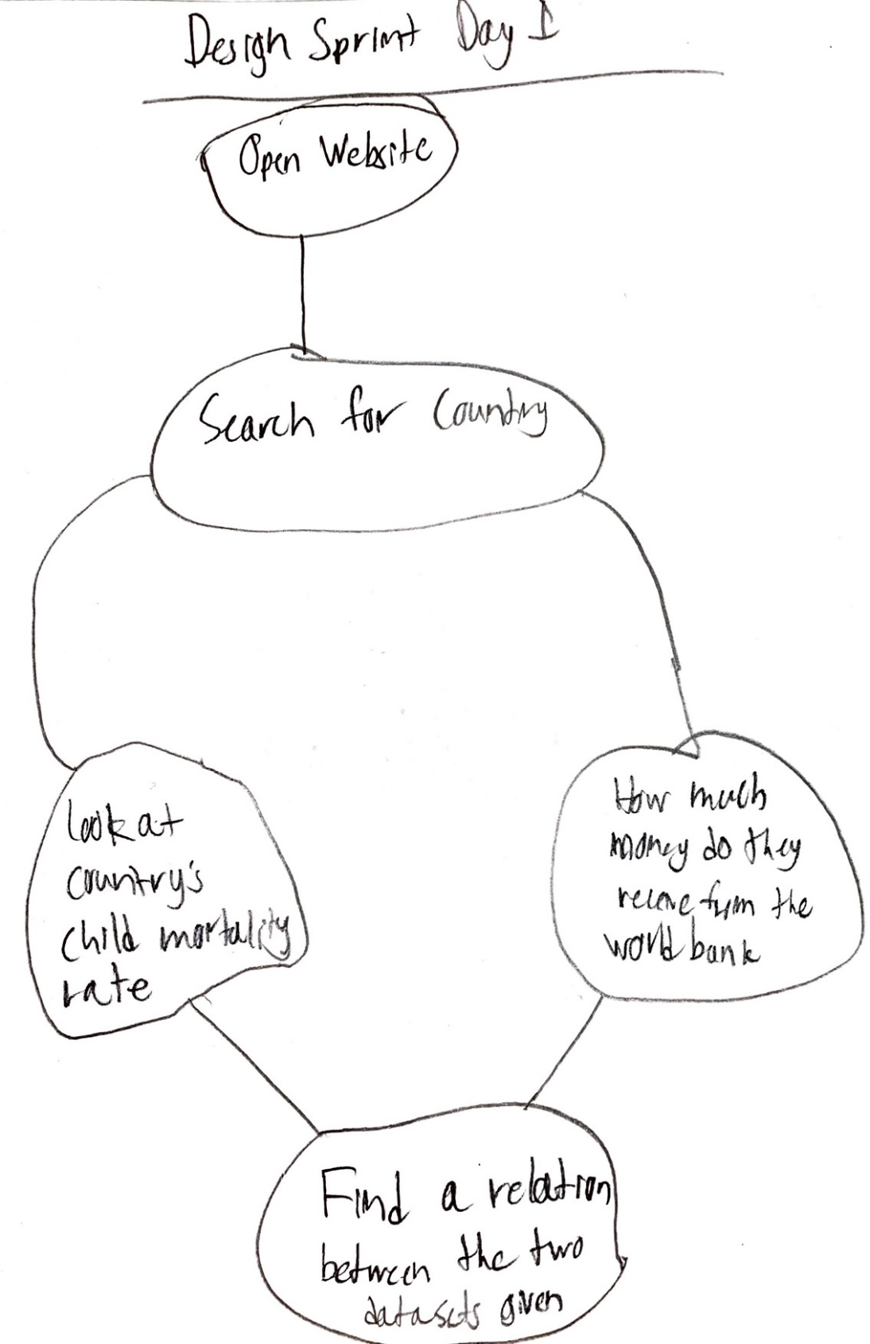

(questions five and six are at the bottom)

5.) Finally use your map to write scenarios and user stories.

Scenarios:

A person needs to find out the country’s child mortality rate.

A person needs to find how much money the country receives from the world bank.

User stories:

As a person who is accessing the website, I want to find out the correlation between the child mortality rate and how much money the country receives from the world bank, to see if these to categories have any relation.

As a person who is accessing the website, I want to find out how much money a country receives from the world bank, so that I can use the data to finish an analysis on the world’s economy.

6.) From your scenario and user stories develop a feature list

* A website that contains the information listed in the map.
* Ability to search for countries.
* Data sets that display two types of information, a country’s child mortality rate and how much money that country receives from the world bank.
* Finding out the correlation between the two mentioned data sets.